Clawdbot, risk, and personal responsibility
If you're freaking out about AI security, read this
Alex McFarland
Jan 30, 2026

I don’t write pieces like this very often.
Most of what I put out is practical—tutorials, walkthroughs, skills you can download and use. That’s my lane. I’m not really here to write opinion pieces or hot takes (at least not yet).
But this one felt necessary.
OpenClaw has changed names three times in the past week.
It started as Clawdbot. Clawdbot became Moltbot. Moltbot became OpenClaw. Anthropic asked them to change it (the “Clawd” was too close to Claude). And then I guess Moltbot just didn’t have a nice ring to it. So now we’re at OpenClaw—and apparently this one’s sticking.

OpenClaw🦞@openclaw
The lobster has molted into its final form 🦞 Clawd → Moltbot → OpenClaw 100k+ GitHub stars. 2M visitors in a week. And finally, a name that'll stick. Your assistant. Your machine. Your rules. openclaw.ai/blog/introduci…
openclaw.ai
Introducing OpenClaw — OpenClaw Blog
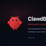
12:12 AM · Jan 30, 2026 · 1.15M Views

912 Replies · 744 Reposts · 7.76K Likes
If you’ve been trying to follow along, I don’t blame you for being confused. I’m deep in this stuff and even I’m having trouble keeping up.
But the name changes aren’t what matters. What matters is understanding what this tool actually does, whether you want to use it, and if so—how to do it responsibly.
Because there’s been a lot of noise around OpenClaw lately. A lot of hype. A lot of backlash against creators who are pushing it without talking about security. And a lot of people freaking out about the risks.
I want to address all of that.

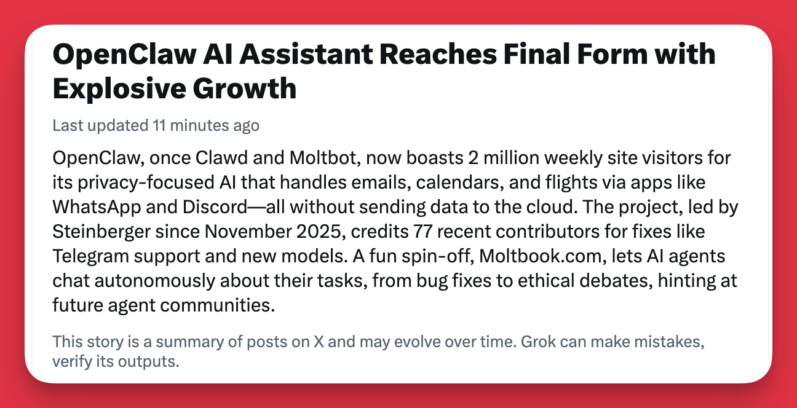

What OpenClaw actually is
If you haven’t been following, OpenClaw is an autonomous AI assistant that runs on your own machine—Mac, Windows, Linux, or a VPS. You interact with it through chat apps like WhatsApp, Telegram, iMessage, or Discord.
It’s way more than a chatbot. It can execute shell commands, read and write files, control your browser, manage your calendar, send emails, check you in for flights. It has persistent memory. It learns your preferences. You can text it like you’d text an assistant, and it just handles things.
I’ve been working with AI for six or seven years, and this is the most excited I’ve been about anything in that entire time. Not because of hype. Because of what it actually does. I’m even more excited because of what it means. It’s Claude Code on steroids—an autonomous AI that can work across your entire system.
I put out a guide yesterday showing how to set it up on DigitalOcean (VPS) in under five minutes. One-click VPS, no dev experience needed.
But before you set anything up, you need to understand what you’re getting into.

The security reality
OpenClaw’s own documentation states that prompt injection is “not solved.” The AI can be manipulated through untrusted content—web pages, attachments, messages from unknown senders. Browser control is described as “remote code execution equivalent.”
This is a tool that can execute arbitrary shell commands on your machine, access your network, read and write files, and send messages to anyone if you give it access.
That’s what makes it powerful. That’s also what makes it risky if you don’t know what you’re doing.
The DigitalOcean setup I showed mitigates some of this. Their VPS comes with authenticated gateway tokens, firewall-level rate limiting, container sandboxing, non-root execution. It’s more locked down than running this raw on your local machine.
But “mitigated” doesn’t mean “eliminated.” You’re still giving an AI system significant access. You need to understand what that means.

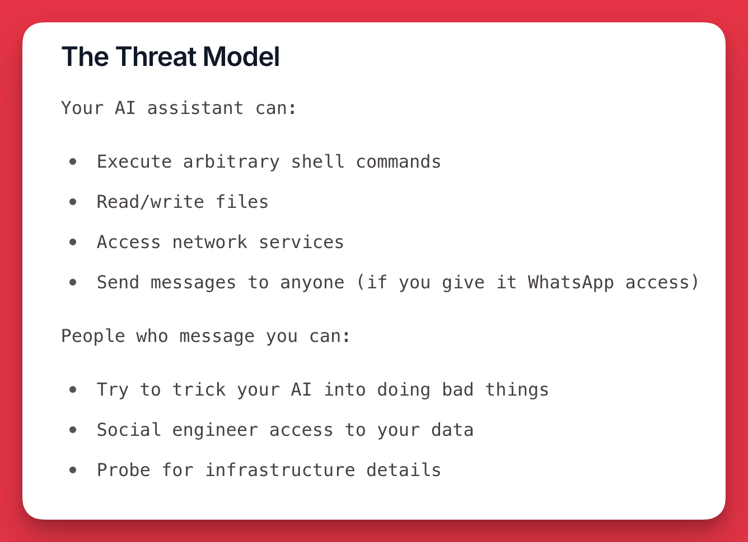

My honest opinion on all of this
I’m seeing a lot of backlash right now against AI creators who push tools like this without disclaimers. And I get it. If you’re introducing people to something powerful, you should be upfront about the risks.
But I’m also going to say something that might be unpopular: this should be obvious.
We are working with a fundamentally new technology. AI systems that can execute code, access files, browse the web, send messages on your behalf. If you’re giving any tool—AI or otherwise—access to your API keys, your computer, your accounts, your data—you should automatically be cautious.
You wouldn’t hand your credit card to a stranger on the street. You wouldn’t give admin access to your computer to some random app you downloaded without reading what it does. The same thinking applies here.
I don’t think it should be necessary to explain this over and over again every time a new AI tool comes out. If you’re working with AI at this level, there’s a baseline responsibility to understand what you’re working with. To read the documentation. To think about what access you’re granting. To not just blindly follow a tutorial because it looks cool.
That’s not me being dismissive of security concerns. The concerns are real. It’s me saying that personal responsibility is part of the deal when you’re working on the cutting edge. And at the end of the day, it’s the only thing you can actually control. Creators can guide you. Developers can build guardrails. But no one is going to care about your security as much as you do.
And for what it’s worth—I’m not a developer. I have zero development experience. Everything I know about this stuff I’ve taught myself over the past couple years, especially with the rise of vibe coding and tools like Claude Code.
I actually operate super paranoid when it comes to security. Something that should probably take me 20 minutes ends up taking two hours because I run it through Claude over and over again. I ask it to explain everything to me. I give it screenshots. That’s just how I operate.
So when I say “personal responsibility,” I’m not telling you to YOLO and figure it out. I’m telling you to be careful, do your homework, and don’t rush through things you don’t understand. That’s what I try to do.

The spectrum of risk tolerance
Here’s how I think about it.
There are two lanes you can be in with AI right now:

Lane 1: Enterprise tools with guardrails.
Claude. ChatGPT. The big platforms built by companies like Anthropic and OpenAI. These are designed for mass adoption. They have safety rails. They’re sandboxed. They limit what the AI can do specifically because they’re serving millions of people with varying levels of technical knowledge.
If you want to use AI but you’re risk-averse—or you just don’t want to think about this stuff—stay in this lane. These tools are powerful enough for most use cases, and they’re built to protect you from yourself.

Lane 2: Open-source and cutting-edge tools.
OpenClaw. Local LLMs. Autonomous agents with system access. These are more powerful, more flexible, and often ahead of what the enterprise tools can do. But they come with more responsibility.
Open source moves fast. Documentation is sometimes incomplete. Security is sometimes an afterthought that gets tightened up over time by the community. You’re operating closer to the metal, and that means you need to be cautious.
If you’re in this lane. Read the docs. Understand the architecture. Know what access you’re granting. Don’t freak out when something has risks—just understand those risks and make informed decisions.
There’s no shame in picking either lane. If OpenClaw sounds like too much, stick with Claude. You’ll still get a ton of value. And you’ll still be ahead of 99% of people out there. Or just wait for it to mature, which won’t be long.
But if you want to explore the frontier—if you want the most powerful tools, the latest capabilities, the stuff that feels like the future—then accept that it comes with responsibility and risks. Because I predict this is just the first of many tools like this in the next couple years.

If you’re going to follow along with OpenClaw
I’ll be posting more content about OpenClaw. Specifically, how I’m integrating it into co-writing systems, context profiles, workflows. The stuff that’s relevant to what we’re building here.
But if you’re going to follow along, you should build a foundation first. Don’t just spin this up because it looks cool.
Start here:
- OpenClaw Blog — openclaw.ai/blog — The developer posts updates here. Name changes, new features, announcements. Follow this to stay current.
- Security Documentation — docs.openclaw.ai/gateway/security — Read the whole thing. Trust hierarchy, prompt injection risks, access controls, sandboxing, credentials, incident response. This is comprehensive and important. If it sounds too technical, it’s a great opportunity to feed it to Claude and ask for help going through it.
- Full Documentation — docs.openclaw.ai — Architecture, setup options, configuration. The more you understand, the better.
- Follow on X — x.com/openclaw — Real-time updates as this project moves.
- Nate Herk’s breakdown — youtube.com/watch?v=CBNbcbMs_Lc — A solid video that covers OpenClaw from multiple angles. Good for understanding what you’re actually dealing with.
If you don’t want to do that homework, that’s totally understandable. Stick with Claude, stick with the enterprise tools, and check back in six months when this stuff is more mature and locked down.
But if you’re ready to explore the frontier, do it with your eyes open.

Where I stand
I’m going to keep building with OpenClaw. I have it running on an isolated Mac Mini right now, integrated with iMessage, working alongside my co-writing systems. It’s insane what this thing can do.
I’m not here to do comprehensive setup tutorials—there are a million videos on that. And my community is not all about OpenClaw, or any single tool. It’s about building across all of them. What I’m interested in is the application layer. How this fits into content production. How to feed it context profiles. How to build real workflows on top of it.
That’s what I’ll be sharing.
But I wanted to put this out first. Because if you’re going to follow along (me or anyone else talking about OpenClaw), you should know what you’re getting into. Never rely 100% on others.
That’s always been the deal with new technology. AI is no different.

